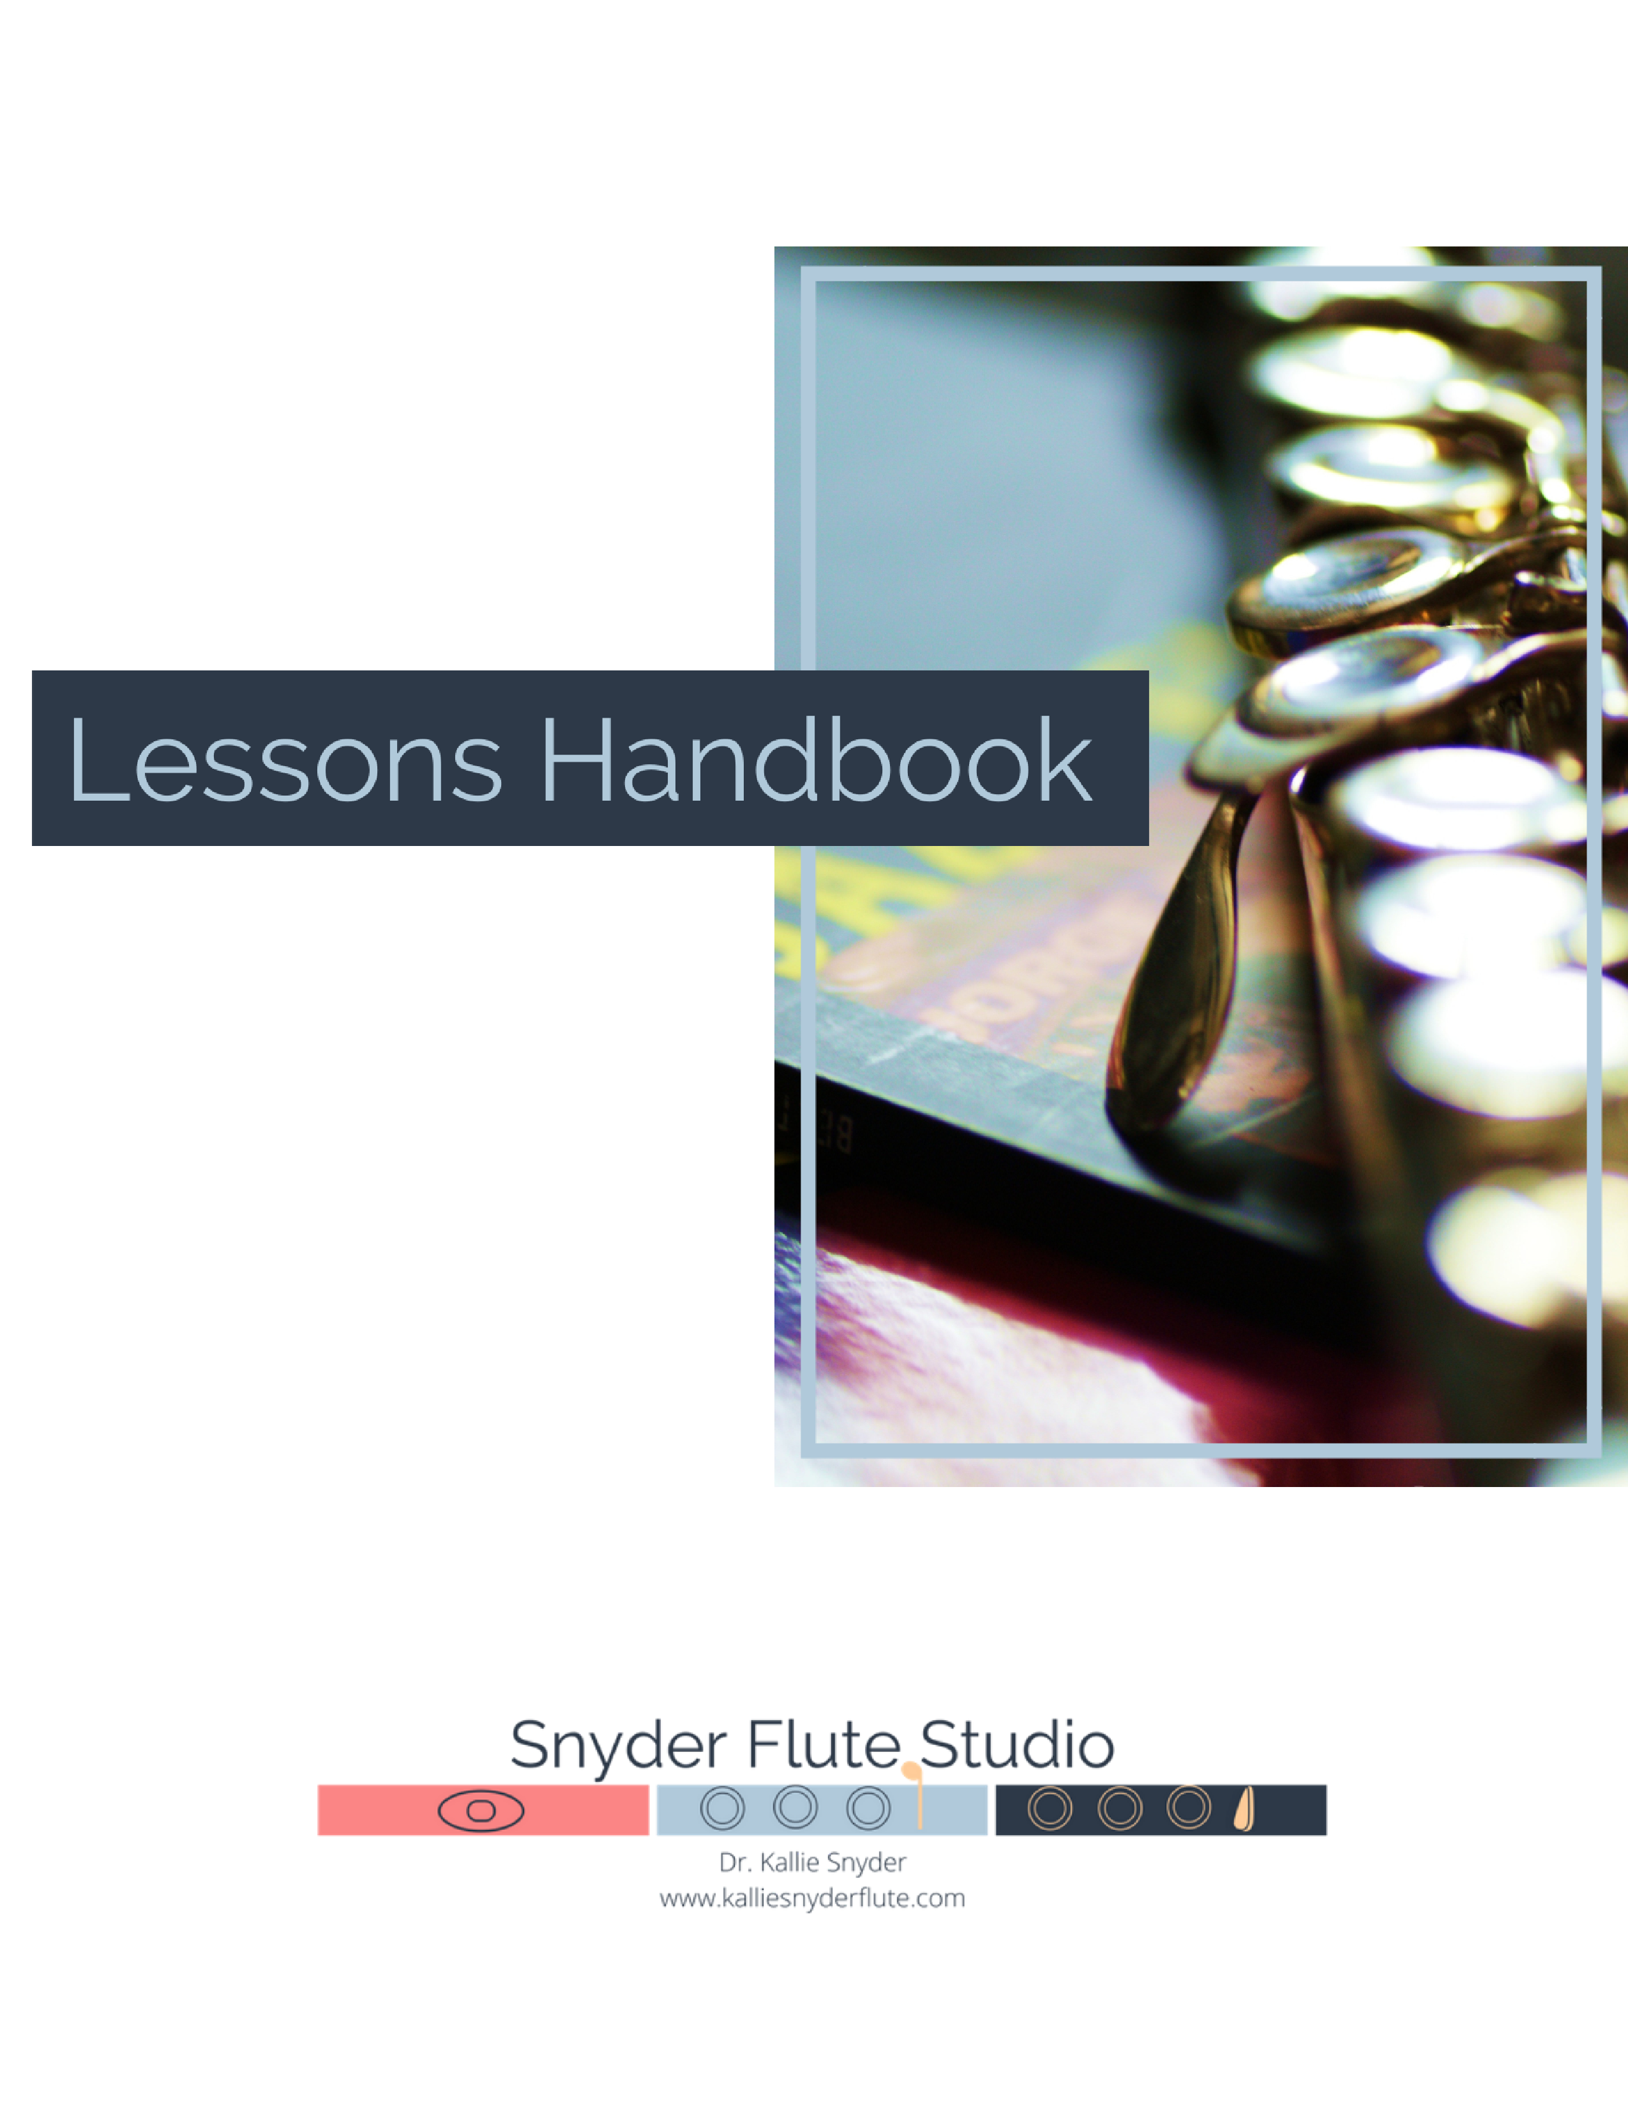

Hi, there!

Welcome to the Snyder Flute Studio! Whether you’re a student or a parent, I first want to say thank you for entrusting me with your or your child’s musical journey.

As a high school student in rural Kentucky, I was fortunate to have a flute teacher that believed in me, encouraged me, and taught me how to trust in my own creativity and abilities. Her investment in me is what inspired me to become an educator myself.

Now, after three degrees in music, over a decade of private teaching, and almost two decades of flute playing, I am honored to serve *you*. I can’t wait to get to know you during our lessons together, and I’m excited to help you start reaching your musical goals!

In this handbook, you will find more information about my teaching philosophy and methodology, what to expect in lessons, and more.

Thank you, again, for choosing me as your “flute guide” – let’s get started!

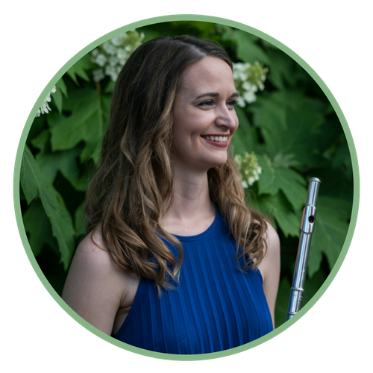

**-Dr. Snyder**

Teaching Philosophy

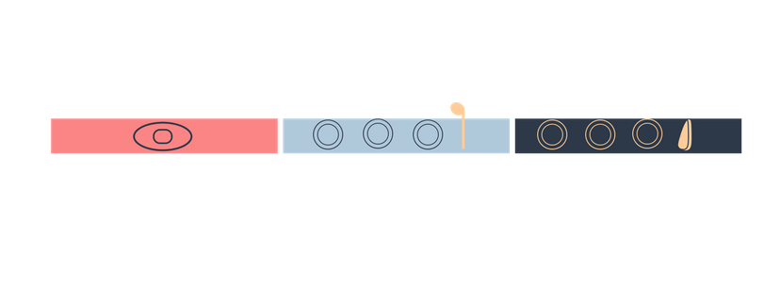

I am a teacher because I had a phenomenal teacher in high school that believed me, encouraged me, and taught me to believe in myself.

I teach music because I believe it is a powerful and essential component of the human experience.

In my eyes, my first job as a teacher is to **empower** you. To help you see the potential in yourself and to **encourage** you on your musical journey. I promise that I will always be on your team; I will always be honest; and I will always keep your best interests at heart.

This means helping you play with **ease** and practice with **efficiency**.

I am committed to helping you play with a healthy and comfortable posture and hand position so that you can enjoy playing the flute all your life! And while regular practice is integral to improvement on the instrument, I firmly believe that we are better and happier musicians when we live full lives and aren’t stuck in a practice room all day. As a member of my studio, you will learn how to practice thoughtfully and efficiently, so that you make more progress in less time, and can spend more time doing the other things that bring you joy besides music.

In that vein, we are flute PLAYERS. We get to PLAY music. But we are so often caught up in trying to play “right” that we forget to have fun and just **play**!

Musicianship is a *process*. Some aspects of playing may come to us quickly, but more often than not, they come slowly with much time, patience, and diligence, but this should not be at the expense of **enjoying music**, which is why lessons are structured to incorporate fun extended techniques, duets, and improvisation games that both **balance** and **enhance** the work that we will be doing to prepare your playing test, audition music, or solo.

After all, the flute player is, foremost, a person, and I believe in taking the time to understand the goals, motives, concerns, and learning preferences of all my students and discovering what teaching strategies best serve each one. This is why I’ve come to appreciate and use, to the best of my ability, a **holistic** and **personal** approach to teaching the flute.

Whatever your goals may be – if it’s to play your first tune as a beginner, earn a spot in the All-District or All-State Band, gain entrance into a college music program, or maybe rekindle your relationship with the flute after a *few* years off – I strive to give you the tools in every lesson to improve a little by little each week and enjoy the process along the way.

Teaching Methodology



We will work in four main areas during lessons:

**Performance**

How to physically play the instrument, including guidance on body alignment and hand position, breathing, embouchure formation, tone production, vibrato, intonation, articulation, and finger technique.

Along with understanding how to play the instrument, you will also learn how to practice in a way that is fun, effective, and healthy! I love using “non-traditional” methods to strengthen fundamentals like singing and playing, flutter tonguing, beatboxing, and physical exercises like standing on one foot or “wobbling” on the wobble disk!

**Comprehension**

Reading and interpreting music, including the basics of music theory (note reading, counting rhythms, and interpreting other musical markings) as well as music history (composer background, the style of each musical period, etc). These concepts are reinforced through shared playlists, apps, handouts, and online resources when appropriate.

**Expression**

Bringing the music to life! You will learn how to use expressive tools (dynamics, vibrato, tone colors, articulations, and phrasing) to put your own personal mark on the music! We do this through improvisation exercises, games, and extensive use of erasable colored pencils!

**Confidence**

The way we feel about ourselves has a direct correlation with our productivity in the practice room and the success of a performance, audition, etc., which is why your thoughts and feelings are a priority to me! Through mindfulness and self-awareness exercises along with instruction in stage presence and audition strategies, I want to give you the courage and the confidence to express yourself through music.

Studio Policies



**Tuition Rates & Payment**

At this time, flute lessons will be conducted online via Zoom through December 31st, 2020. Safety of all students and families is my utmost priority. In-person options will be reevaluated at the end of the year and communicated before January 1st, 2021.

|  |  |  |
| --- | --- | --- |
|  | **Online Rate (per lesson)** | **Per month (4 lessons)** |
| **30 minutes** | **$20** | **$80** |
| **45 minutes** | **$30** | **$120** |
| **60 minutes** | **$40** | **$160** |

**Payment Options:**

At this time, electronic payments are preferred and can be made via Zelle, Venmo, or PayPal using the email address [kalliesnyderflute@gmail.com](mailto:kalliesnyderflute@gmail.com).

*\*\*If using PayPal, please submit payment via an ACH Bank Draft, if possible, to avoid credit card fees.*

Payment is due on your date of choice – the 1st, 5th, 10th, or 15th – of each month. Failure to pay tuition 10 days after the due date will result in a $20 late fee.

For a 10% discount, full semester tuition payments may be made in the first month of each term (September, January, June).

To schedule a lesson

Please email me at kalliesnyderflute@gmail.com.

**Materials**

Student will bring to each lesson:

* Flute, in good working order
* Assigned lesson materials

*the instructor will provide *select* materials, other assigned repertoire must be purchased by the student

* Flute notebook/paper for notetaking
* *Optional: personal recording device

Recommended materials for home practice:

* Cleaning rod with swab
* Music stand
* Tuner
* Metronome
* *Optional, but recommended:personal recording device

**Lesson Expectations**

Students are expected to be respectful and courteous during the lesson.

I encourage students to be fully engaged during our lesson time and to feel free to voice any observations or concerns and ask questions.

Parents are welcome to sit in on the first lesson (including Zoom!) and at any point during our course of study if you have questions about the process or want to discover how you can help your child practice better at home!

However, I have found that most students, even the youngest ones, are more open and receptive in lessons without parent observation, and they generally prefer the one-on-one time.

Practice Requirements

Students gain the most out of lessons by reinforcing learned concepts regularly at home. I understand that life happens, and it may not always be possible to practice as much as we’d like, but in general, I recommend the following for at home practice:

Beginners (5th-6th grade or other beginner): 10-20 min/day 5x per week

Intermediate (7th-8th grade): 20-30 min/day 5x per week

Advanced Intermediate (10th-12th grade): 30-45 min/day 5x per week

Advanced (college music major bound): 45 min-1.5hrs/day 5x per week

**Communication**

Students and parents are free to contact me by phone, text, or email. Messages left after 8pm will be returned the following business day.

I prefer school-age students to address me as “Dr. Snyder.” Parents and adult students are free to call me by my first name.

**Attendance**

Tardiness

In the event that lesson minutes are lost due to tardiness, lesson time will not be made up and are not subject to an additional lesson. **Please have all equipment ready and be prepared to join the Zoom lesson on time.** Lesson minutes lost via tardiness by the teacher are subject to proration.

Absences

Please notify me of any planned absences 24 hours in advance of the scheduled lesson time via text, phone, or email. One makeup lesson will be granted to each student per month if proper notification has been given. The student will have 30 days from the missed lesson to schedule a makeup. After 30 days, the lesson is forfeited.

Less than a 24-hour notification or no notification of a planned absence will forfeit the lesson without a makeup or a credit.

Illness/Emergencies

If you are sick and unable to attend your online flute lesson, please notify me as soon as possible, and we will reschedule.

Internet/Power Outages/Other technology issues

I understand that technology issues are often inconvenient and unexpected! If there is an issue that prohibits you from attending your online lesson, please inform me as soon as possible, and I will try to recover lost lesson minutes if my schedule allows, or we can reschedule. I will do the same.

Holidays

No lessons will be given on Thanksgiving, Christmas Eve/Day, New Year’s Day, Easter, or July 4th. Students will not be billed if their regularly scheduled lesson time falls on one of these holidays.

Lesson Change

Lesson times may be changed at any time during the year pending availability. Lesson suspension (vacation or holidays) must be communicated two weeks in advance. Failure to do so will result in a full monthly fee.

Lesson Termination

If you wish to terminate lessons, please notify me a minimum of two weeks prior to termination. Failure to do so will result in a full monthly fee.

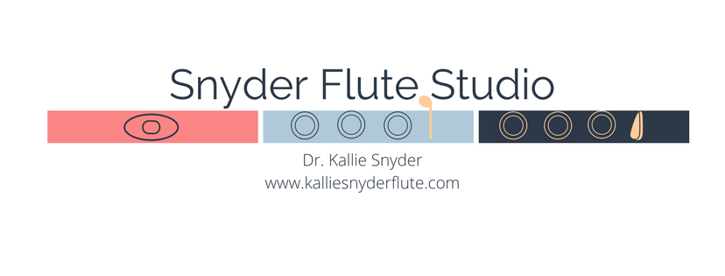

Lesson Contract

Contact Information

**STUDENT NAME** Click or tap here to enter text.

**STUDENT BIRTH DATE** Click or tap here to enter text.

*For returning students, only fill out the remaining contact info if there have been changes.*

**GUARDIAN NAME(S)** Click or tap here to enter text.

**EMAIL** Click or tap here to enter text.

**HOME PHONE #** Click or tap here to enter text.

**CELL PHONE #** Click or tap here to enter text.

**PREFERRED METHOD OF CONTACT (please check all that apply)**

**Call  Text  Email**

Lesson Information

**LENGTH OF LESSON:** select one

**LOCATION: ONLINE ONLY**

**FREQUENCY:** select one

**PAYMENT:** select one

Tuition Amount

$ type amount here per month, due on the **select one** of each month. Based on 4 lessons per month. Occasionally, there are 5 lessons in a month. Payment should be adjusted accordingly in those circumstances.

OR

$ type amount here per semester, due on date of first lesson for the current term.

Agreement to Terms and Conditions

Please sign below to acknowledge that you have received a copy of studio policies and agree with all terms and conditions, including tuition commitment.

Click or tap here to enter text. Click or tap to enter a date.

Print Name Date



Digital Signature (double click to sign)

Dr. Kallie Snyder

Snyder Flute Studio

1101 Beaumont Centre Ln

Lexington, KY 40513

270-543-7698

kalliesnyderflute@gmail.com

www.kalliesnyderflute.com